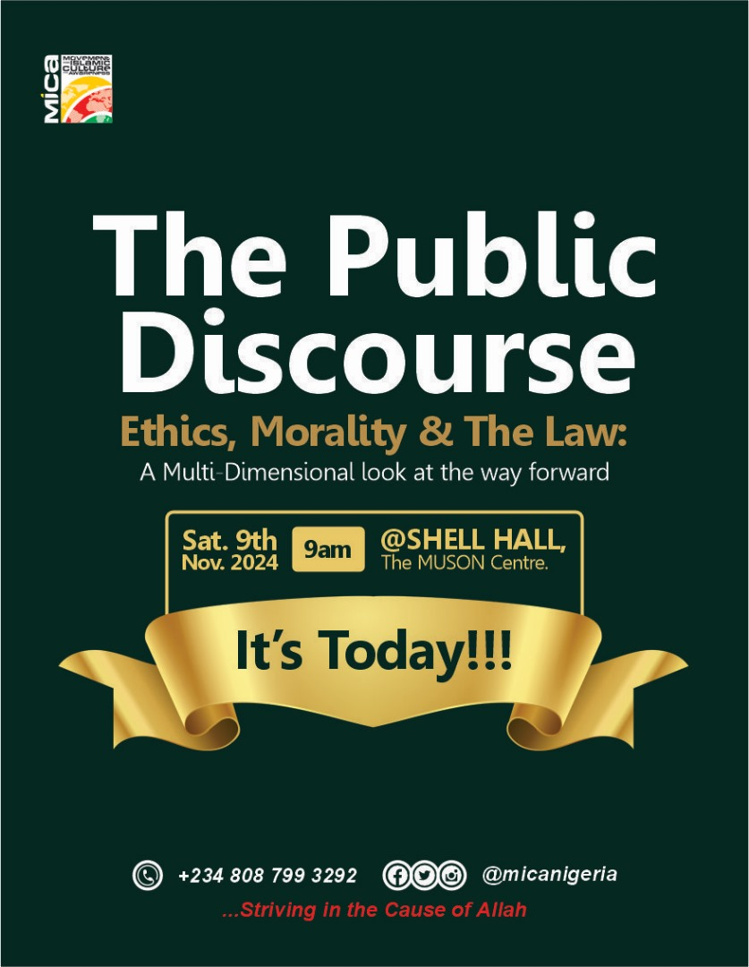
THE PUBLIC DISCOURSE AND MICA’s 30TH ANNIVERSARY
Organised by: The Movement for Islamic Culture and Awareness (MiCA)
Date: Saturday, November 9th 2024
Venue: Shell Recital Hall, MUSON Center, Lagos

EVENT REPORT

- Executive Summary:
This report details the successful execution of the Public Discourse titled ‘Ethics, Morality and the Law’ organised by the Movement for Islamic Culture and Awareness (MiCA) in celebration of its 30th Anniversary and the elevation of Hon. Justice Habeeb Wale Abiru (JSC) to the Supreme Court. The event held on Saturday, the 9th of November 2024 at the Shell Recital Hall, MUSON Center, Lagos State.

The Public Discourse sought to foster thoughtful discussions in the intricate relationship between Ethics, Morality and the Law in a contemporary society. It brought together a diverse audience such as: Hon. Justice Kudirat Kekere-Ekun (CJN, CON)- the Chief Justice of Nigeria, the 19 Justices of the Supreme Court inclusive of Justice Wale Abiru, the Grand Khadi, Former Governor- Mr. Babatunde Raji Fashola (SAN), Rev. (Prof.) Konyinsola Ajayi, Media Houses to mention a few. Virtual attendance (Zoom and YouTube) also recorded the presence of the Governor of Kwara State and many others.

Through an engaging keynote address by the CJN, panel discussions, interactive Q&A sessions, participants explored various themes including the ethical foundation of law, the challenges of balancing moral principles with legal requirement ‘what the law is vs. what the law ought to be’; and the role of law in the society.

The event was well attended with 604 physical attendees and about 200 virtual participants on Zoom and YouTube. Positive feedback was received from attendees, who appreciated the insightful discussions and the opportunity to engage with experts in the field. The discourse achieved its objectives of raising awareness, stimulating intellectual interactions and fostering collaboration among stakeholders.

- Objectives:
- To provide a platform for stakeholders and the public, in this case the Public Discourse, to engage in thoughtful discussions on the intersection of Ethics, Morality and the Law
- To examine the ethical foundations of legal systems and the role of morality in shaping legal norms and practices
- To explore the challenges and contradictions that arise between moral principles and legal requirements
- To generate recommendations through the development of Policy Briefs for strengthening the alignment between Ethics, Morality and the Law

- Keynote Address: The keynote address was delivered by Hon. Justice Kudirat Kekere-Ekun, the Chief Justice of Nigeria. Key points from the address include:
The Interplay of Ethics, Morality and the Law
- The three concepts are interconnected and essential for societal order.
- Law, ethics, and morality influence each other.
- Religion and tradition play a significant role in shaping these concepts.
The Role of the Legal Practitioner
- Lawyers must balance legal obligations with ethical considerations.
- They navigate the intersection of law, ethics, and morality.
- The legal profession requires a commitment to justice and ethical conduct.
Public Perception and Trust in the Judiciary
- Public trust in the judiciary depends on alignment with moral and ethical standards.
- The law must be clear, stable, and independent.
- Ethical conduct is crucial for maintaining public trust in the legal system.
The Impact of Ethics, Morality, and Law on Society
- These concepts shape societal norms and expectations.
- They influence the development of legal systems and institutions.
- A balance between law, ethics, and morality is necessary for societal advancement.
- Panel session: A panel of 4 discussed around the topic of discourse, Ethics, Morality and the Law looking at several perspectives; the Legal, Religious and Layman perspectives. The panelists include Mr. Babatunde Raji Fashola (SAN), Rev. (Prof.) Konyinsola Ajayi, Prof. Adele Jinadu, and His Eminence-Sanusi Lamido Sanusi

M&E REPORT
- PUBLIC DISCOURSE IMPACT ANALYSIS REPORT (%)

A comprehensive monitoring and evaluation plan was implemented to assess the effectiveness of the event. Key Performance Indicators (KPIs) were tracked, including:
- Total # of participants: Disaggregated as: % male, % female
- % of participants expressed satisfaction with the event
- % of participants expressed the relevancy of the discourse topic
- % of respondents expressed that the event was impactful
- Total # of Media Links generated from the event
Overall Assessment: The public discourse was deemed a success by the majority of respondents. The event was well-timed and impactful, with a highly relevant topic.
Specific Findings (Quantitative Analysis):
- Attendance: The event was well attended, featuring:
Physical Attendance: 604 participants, disaggregated as: 354 male and 250 female, represented as 60% and 40% of the total number of attendees respectively. This exceeded our 500 initial target by 83%
Virtual Attendance: 200 participants (Zoom and YouTube)

Figure 1.0.
- Event Quality: 100% of respondents rated the event as good reflecting their satisfaction with the event
- Topic Relevance: 95% of respondents found the topic to be relevant.
- Impact: 90% of respondents believed the event was impactful.
- Timing: 87% of respondents felt the timing of the event was adequate
- Media Links: The event produced media links and footages to a total of 22

Figure 2.0.
Other Findings (Qualitative Analysis):

- The discourse featured dignitaries such as the Chief Justice of Nigeria, 21 Justices of the Supreme Court, Judges, Magistrates, Media outlets, a unique number of Senior Advocates of Nigeria, State Governor (Kwara)
- The event significantly increased public awareness of the complex interplay between ethics, morality, and the law
- The discourse fostered lively and insightful discussions amongst participants
- The event facilitated networking and collaboration among attendees, leading to potential partnerships and future projects
- Several recommendations were generated to strengthen the alignment between ethics, morality and the law across several sectors

Short Term Impact:

- Chief Justice of Nigeria (CJN) led- NJC harmers two judges for age falsification, suspends others https://thereporterng.com/njc-sanctions-two-judges-for-age-falsification/
- The National Judicial Council (NJC) recommends retirement of Imo CJ, Yobe Grand Kadi over alleged age falsification https://thenationonlineng.net/breaking-njc-recommends-retirement-of–imo-cj-yobe-grand-kadi-over-alleged-age-falsification/#google_vignette
- NJC suspends Rivers, Anambra High Court Judges, Recommends Compulsory Retirement for Two others over Age falsification https://thenewsnow.org/index.php/2024/11/15/njc-suspends-rivers-anambra-high-court-judges-recommends-compulsory-retirement-for-two-others-over-age-falsification/
- The Supreme Court dismisses suit instituted by some state Attorneys General challenging the establishment of the Economic and Financial Crimes Commission (EFCC) Act https://www.channelstv.com/2024/11/15/breaking-supreme-court-dismisses-suit-challenging-establishment-of-efcc/

- M&E Recommendations
Based on the evaluation findings, the following recommendations are suggested:
- Continue Organising Similar Events: Given the high level of satisfaction and impact, it is recommended to continue organising similar public discourse events.
- Diversify Topics: While the current topic was well-received, MiCA should consider exploring a wider range of topics to cater to diverse interests.
- Enhance Publicity: Although the publicity (pre and post event) was great, more work can be done to increase publicity efforts to attract a larger audience.
- Seek Feedback: Continue to seek feedback from attendees to improve future events and build the impact of the event over a period of years
- Partner with Relevant Organisations: MiCA can collaborate with other organisations to expand the reach and impact of future events.

- Conclusion:
The Public Discourse on Ethics, Morality and the Law was a resounding success. It provided a valuable platform for dialogue, critical thinking and the exchange of ideas. By addressing pressing ethical and legal issues, the event contributed to a more informed and engaged society. MiCA is committed to organising similar events in the future to continue fostering discussions on important societal issues.

- Some Media Links:

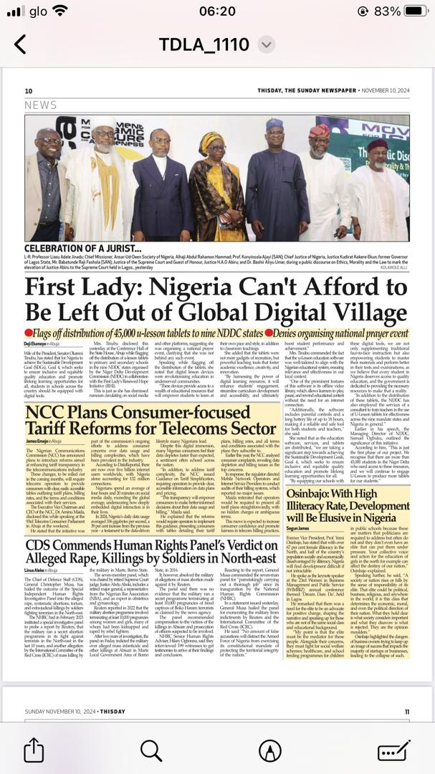

http://opr.news/626b3701241110en_ng?link=1&client=news
https://phoenix-browser.com/BwgtLzApMU4
https://guardian.ng/news/nigeria/national/kekere-ekun-sanusi-others-urge-judges-to-uphold-justice-with-courage/
https://topdailynews.com.ng/judiciary-has-upright-people-but-few-are-tarnishing-our-reputation-cjn/
https://thenationonlineng.net/all-citizens-must-reject-corruption-say-cjn-sanusi-fashola/
https://www.vanguardngr.com/2024/11/some-judges-giving-judiciary-bad-name-cjn/
https://dailytrust.com/some-judges-tarnishing-image-of-judiciary-cjn/
https://tribuneonlineng.com/cjn-kekere-ekun-emir-sanusi-fashola-task-judges-on-justice-accountability/
https://punchng.com/few-judges-give-judiciary-bad-name-cjn/
https://ntm.ng/2024/11/10/judiciary-has-upright-people-but-few-are-tarnishing-our-reputation-cjn/
https://independent.ng/we-have-bad-lawyers-judges-amongst-us-cjn/
https://www.channelstv.com/2024/11/10/judiciary-has-upright-people-but-few-are-tarnishing-our-reputation-cjn-kekere-ekun/
https://m.youtube.com/watch?v=Nun1ZRIn4nc
https://thedefenderngr.com/justice-kekere-ekun-admits-therere-bad-eggs-in-nigerian-judiciary-as-emir-of-kano-urges-judges-against-favouritism/
https://muslimnews.com.ng/2024/11/11/cjn-kekere-ekun-emir-sanusi-fashola-task-judges-on-justice-accountability-at-mica-public-discourse/
https://m.youtube.com/watch?v=Nun1ZRIn4nc
https://thereporterng.com/njc-sanctions-two-judges-for-age-falsification/
https://thenationonlineng.net/breaking-njc-recommends-retirement-of–imo-cj-yobe-grand-kadi-over-alleged-age-falsification/#google_vignette
https://thenewsnow.org/index.php/2024/11/15/njc-suspends-rivers-anambra-high-court-judges-recommends-compulsory-retirement-for-two-others-over-age-falsification/
https://www.channelstv.com/2024/11/15/breaking-supreme-court-dismisses-suit-challenging-establishment-of-efcc/

PHOTO SECTION

